Java Test Local Test

Contents

The request should specify the account id. 1

- The request can specify from date and to date (the date range). 1

- The request can specify from amount and to amount (the amount range). 1

- If the request does not specify any parameter then the search will return three months back statement. 1

- If the parameters are invalid a proper error message should be sent to user. 1

- The account number should be hashed before sent to the user. 1

- All the exceptions should be handled on the server properly. 1

We want to add login and session management functionality. 1

The ‘testadmin’ user is able to perform all the requests (specify date and amount range). 1

- The ‘testUser’ can only do a request without parameters which will return the three months back statement. 1

- When the test user tries to specify any parameter, then HTTP unauthorized access error will be sent. 1

- The user cannot login twice (the user should logout before login). 1

https://blog.csdn.net/bugmanito/article/details/100050575 1

- The session time out is 5 minutes. 1

## We want to add login and session management functionality.

Note: Using springboot security.

Case 1: Unauth user login will prevent and has the error.

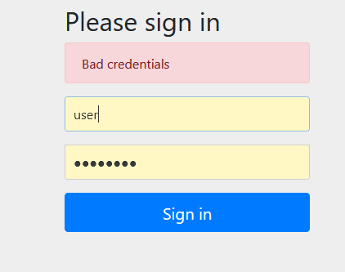

Case 2: testAdmin login

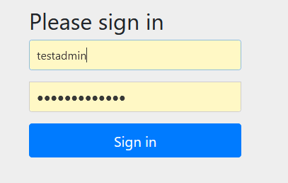

Note: In order to test, change the first five data to the year of 2020.

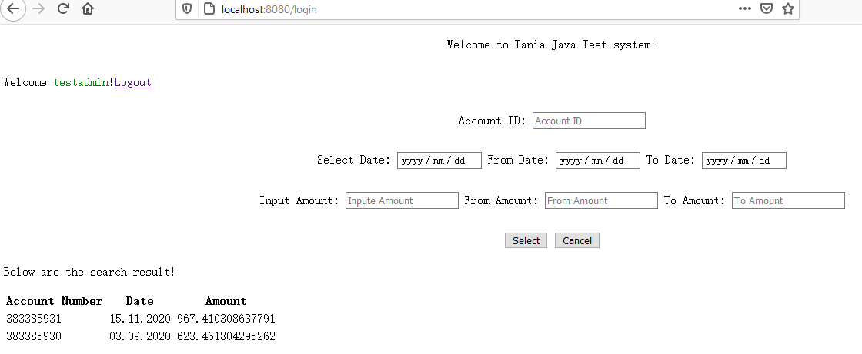

## The request should specify the account id.

Case 1：account ID should not be empty.

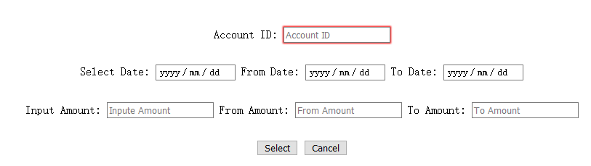

Case 2: Invalid account id will have related error message.

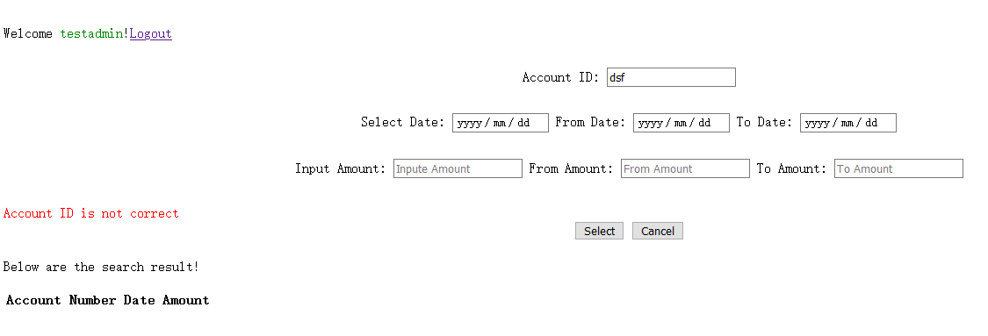

Case 3: Account ID not exist in DB.

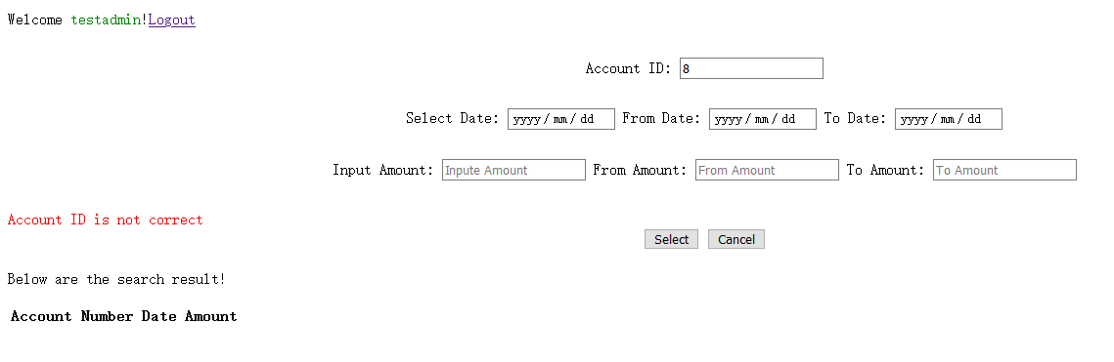

Case 4: Input correct account ID:

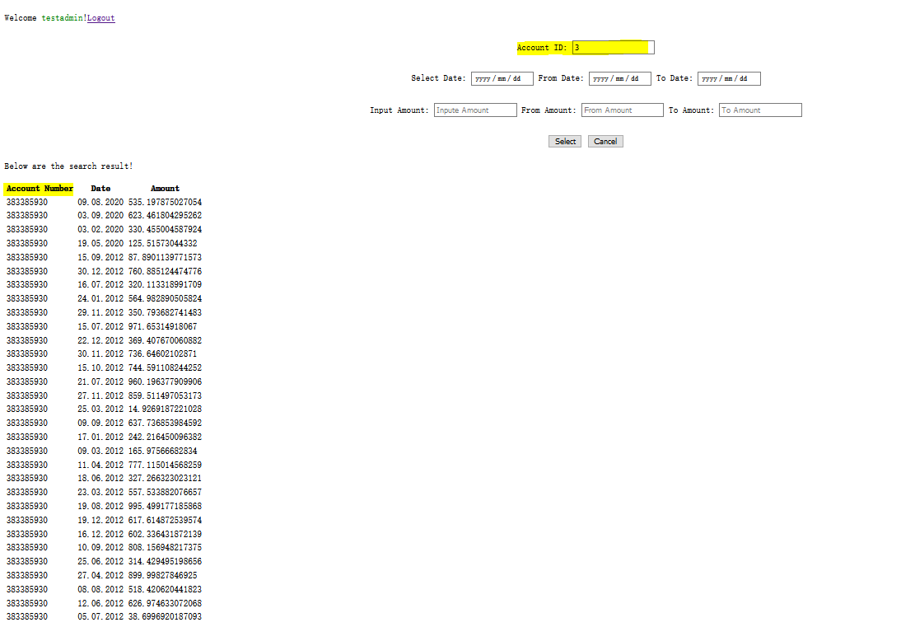

## - The request can specify from date and to date (the date range).

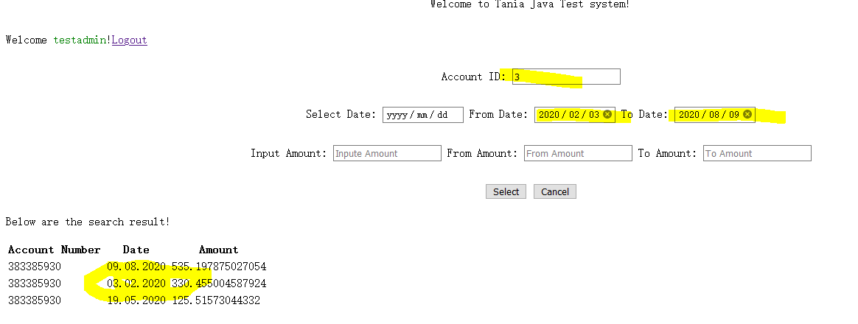

## - The request can specify from amount and to amount (the amount range).

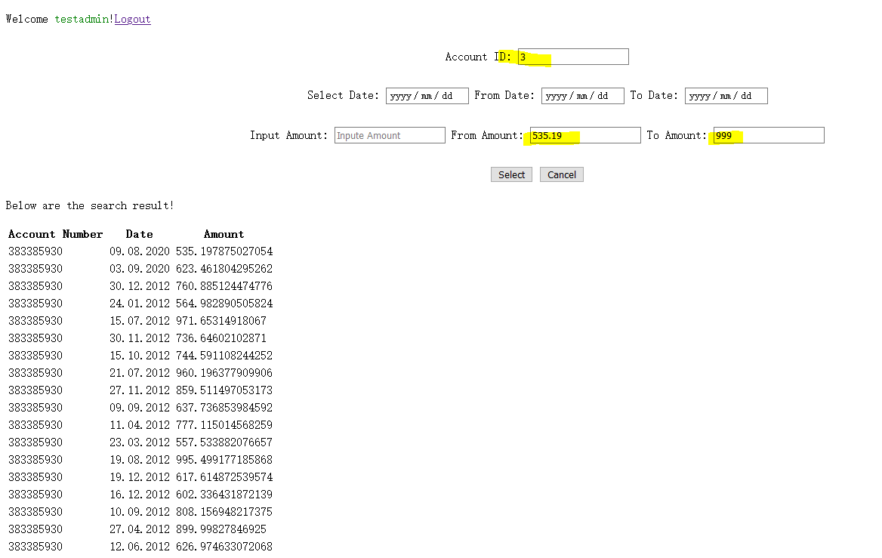

## - If the request does not specify any parameter then the search will return three months back statement.

Note: In order to test, has change some data to 2020 year.

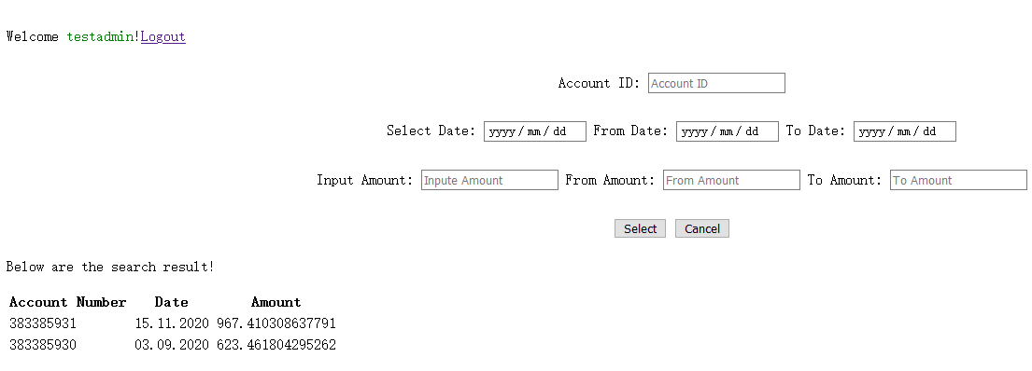

## - If the parameters are invalid a proper error message should be sent to user.

## - The account number should be hashed before sent to the user.

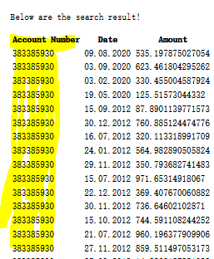

## - All the exceptions should be handled on the server properly.

Note: Will redirect to the error page, for the detailed info, please check GlobalException

## 

## The ‘testadmin’ user is able to perform all the requests (specify date and amount range).

Case 1：Range search for date and amount

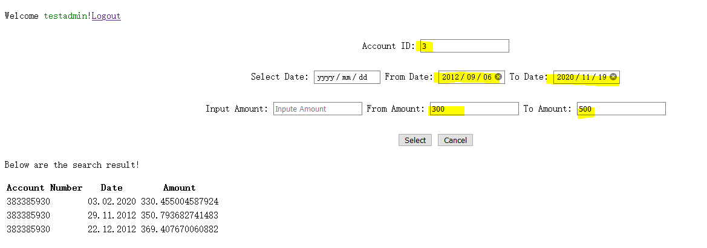

Case 2: Date search.

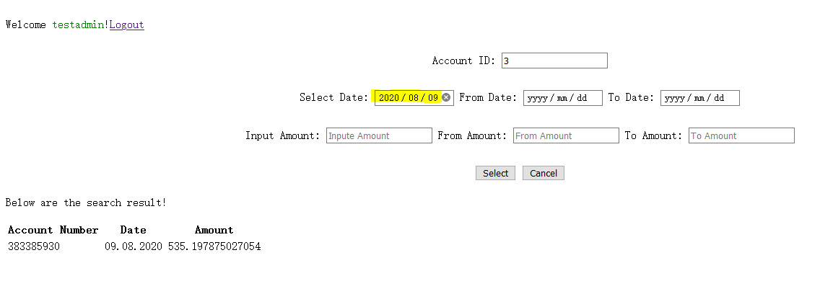

## - The ‘testUser’ can only do a request without parameters which will return the three months back statement.

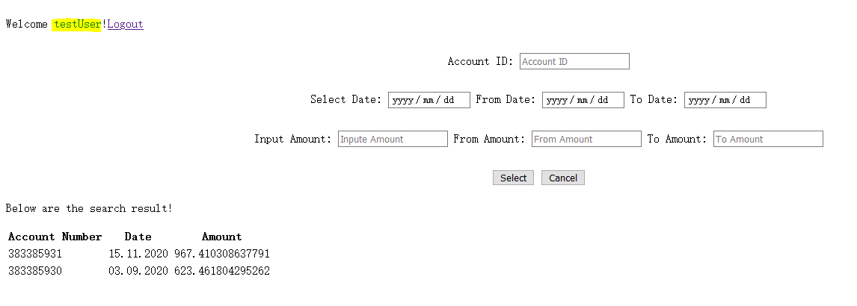

## - When the test user tries to specify any parameter, then HTTP unauthorized access error will be sent.

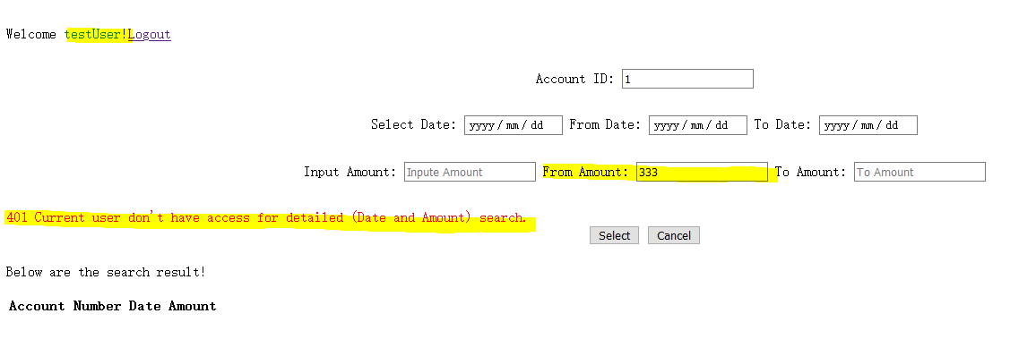

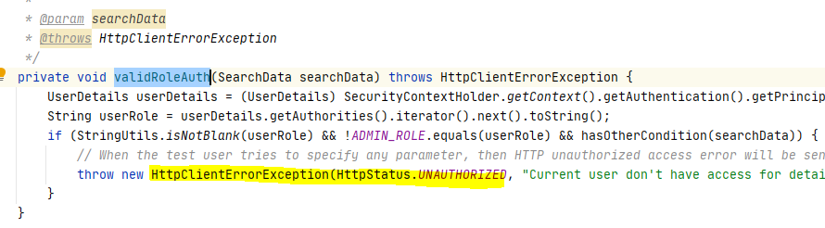

## - The session time out is 5 minutes.

Note: Has config in application.properties

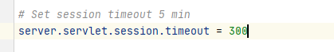

## - The user cannot login twice (the user should logout before login).

Has not add this function and find some related implemention as below blog.

## <https://blog.csdn.net/bugmanito/article/details/100050575>